The main purpose of the AUTOSAR BSW module Com is to provide **a signal-based**

**interface** to the upper layer. In an AUTOSAR based system it is the RTE. In a non-

AUTOSAR system it is the application.

Main Features:

* Provision of signal-oriented data interface for the RTE
* Packing of AUTOSAR signals to I-PDUs to be transmitted
* Unpacking of received I-PDUs and provision of received signals to RTE
* Routing of signals from received I-PDUs into I-PDUs to become transmitted
* Routing of signal groups from received I-PDUs into I-PDUs to become transmitted
* Communication transmission control (start/ stop of I-PDU groups)
* Replications of send requests
* Guarantee of minimum distances between transmit I-PDUs
* Monitoring of receive signals (signals timeout)
* Filter mechanisms for incoming signals
* Different notification mechanisms
* Provision of init values and update indications
* Byte order conversion
* Sign extension
* Support of two different transmission modes per I-PDU
* Signal based gateway
* Support of large and dynamic length data types
* Support of I-PDU counters and I-PDU replication

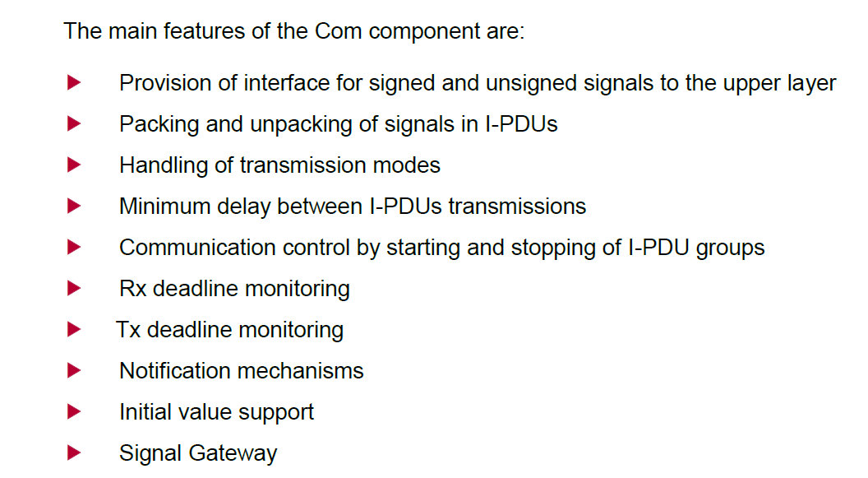

**The AUTOSAR COM module’s interaction model for transmission**

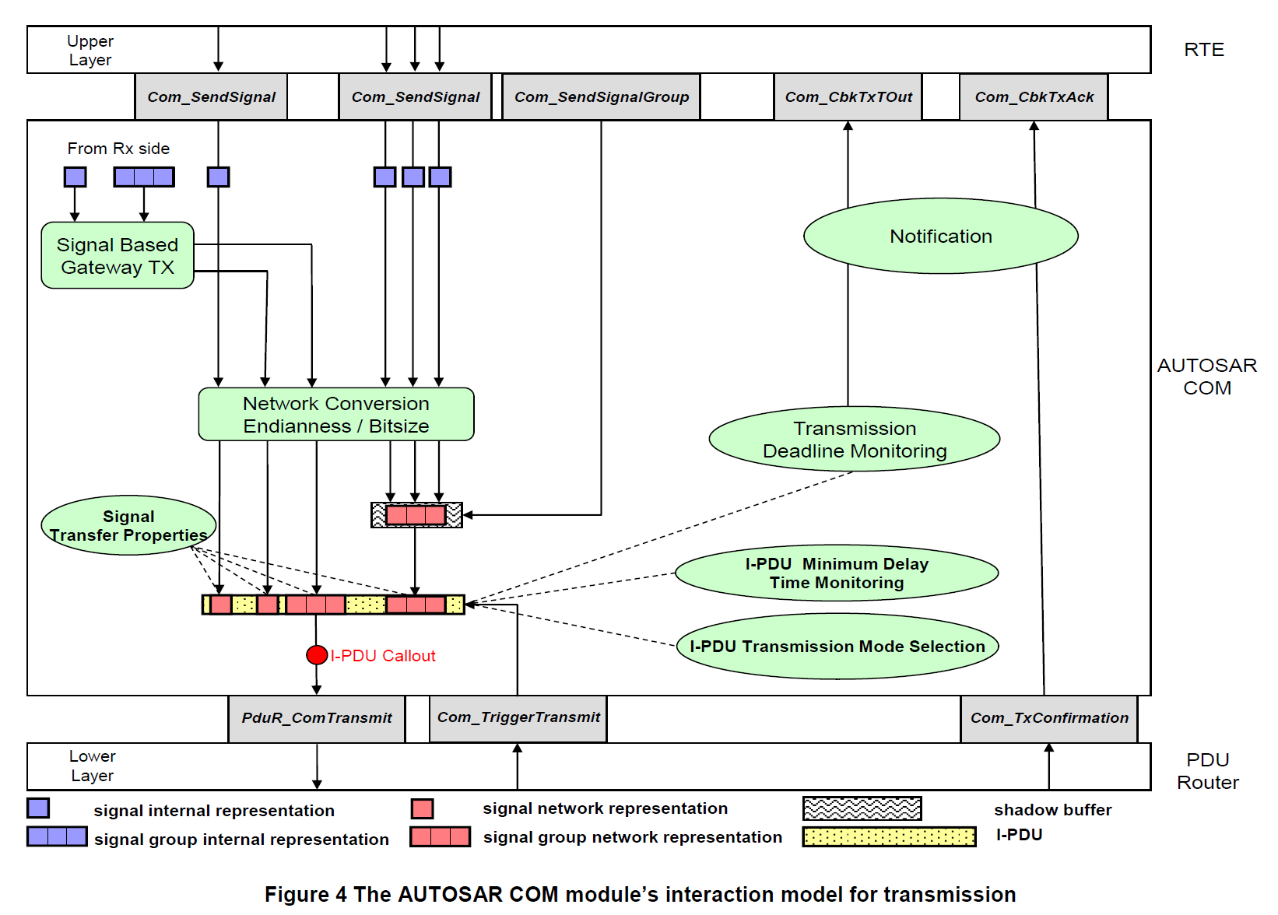

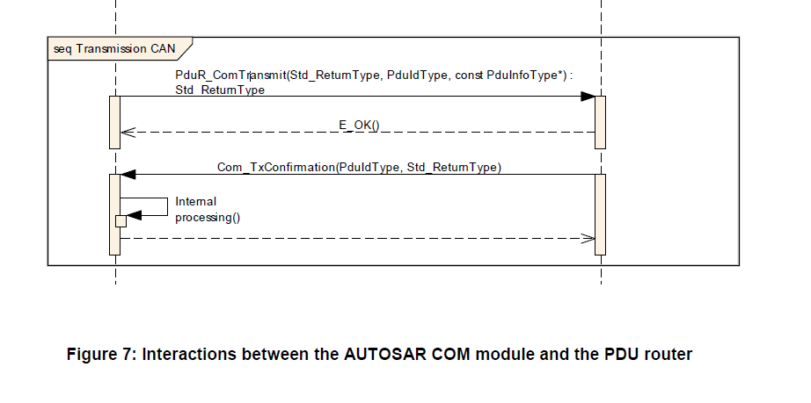

***The key factor used for Transmitting frame ( I-PDU)***

1. ComFilterAlgorithm
2. ComTransferProperty
3. ComTransmissionMode
4. ComTransmissionModeSelection
5. **ComFilterAlgorithm**

A signal filter can be optionally assigned to each transmit signal. The filter of a transmit signal is only used for transmission mode selection but the value of a transmit signal is never filtered out.

The following filters are supported:

* F_Always (TRUE)
* F_Never (FALSE)
* F_MaskedNewDiffersMaskedOld ((new_value&mask) != (old_value&mask))
* F_MaskedNewEqualsX ((new_value&mask) == x)
* F_MaskedNewDiffersX ((new_value&mask) != x)
* F_MaskedNewIsOutside ((new_value<min) || (max<new_value))
* F_MaskedNewIsWithin ((min<=new_value) && (new_value<=max))
* None (The signal has no filter)

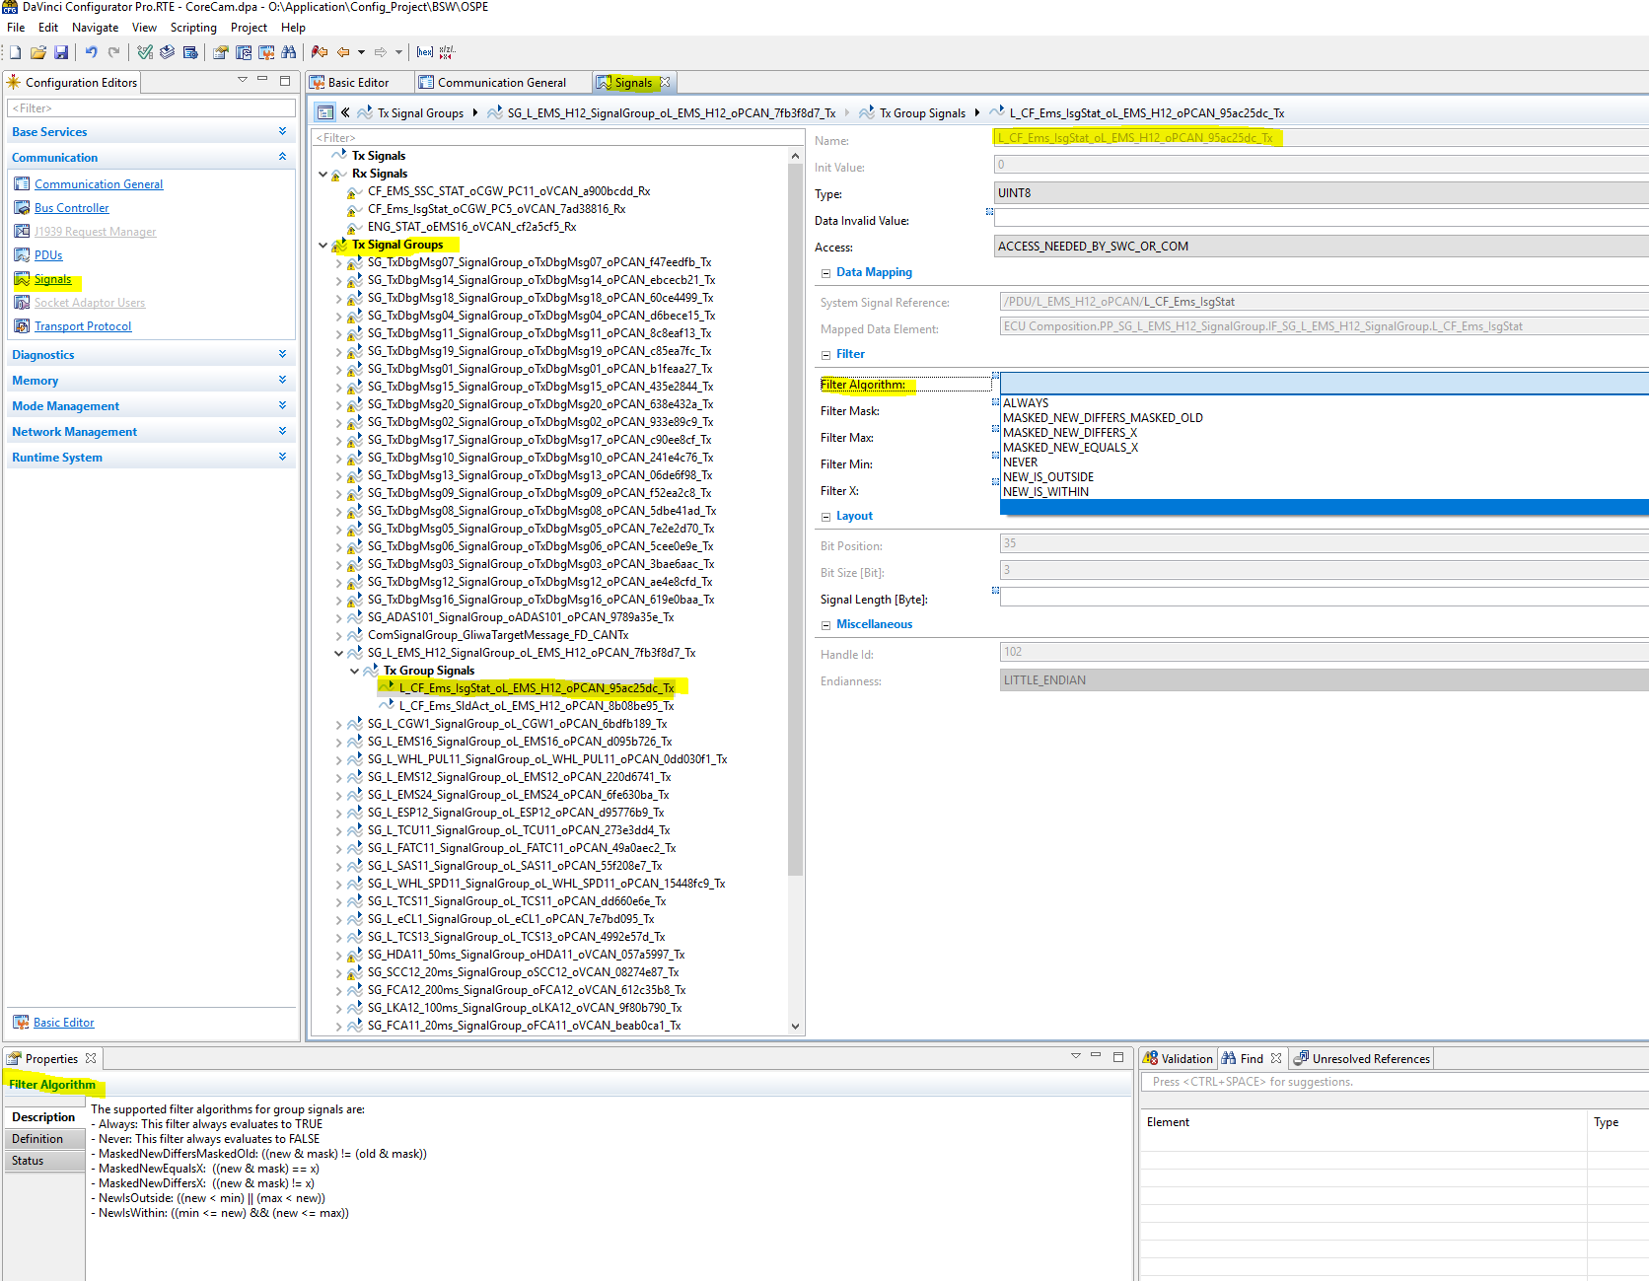

1. **ComTransferProperty**

The AUTOSAR COM module supports several ***transfer properties*** for signals and several ***transmission modes*** for I-PDUs.

In AUTOSAR COM also signal groups and group signals may have a transfer property, defining in combination with the transmission mode, if the I-PDU is sent out in case of an update of a signal group or group signal, respectively.

AUTOSAR COM provides signal groups to send several signals consistently. Signals

mapped to a signal group are called group signals and should be in relationship with each other. To ensure the consistency of the group signal values, a shadow buffer is provided for each signal group.

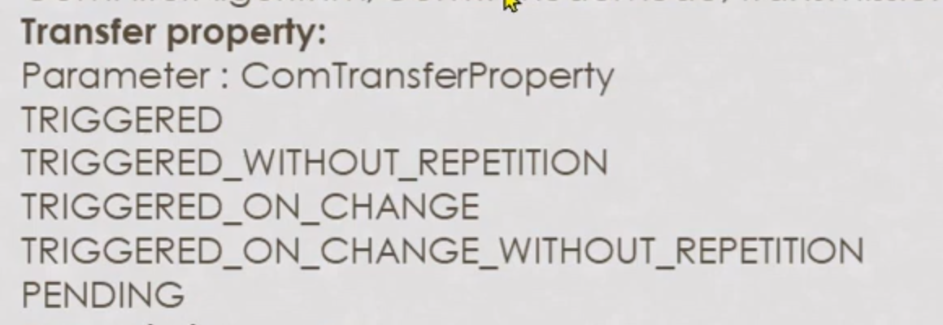

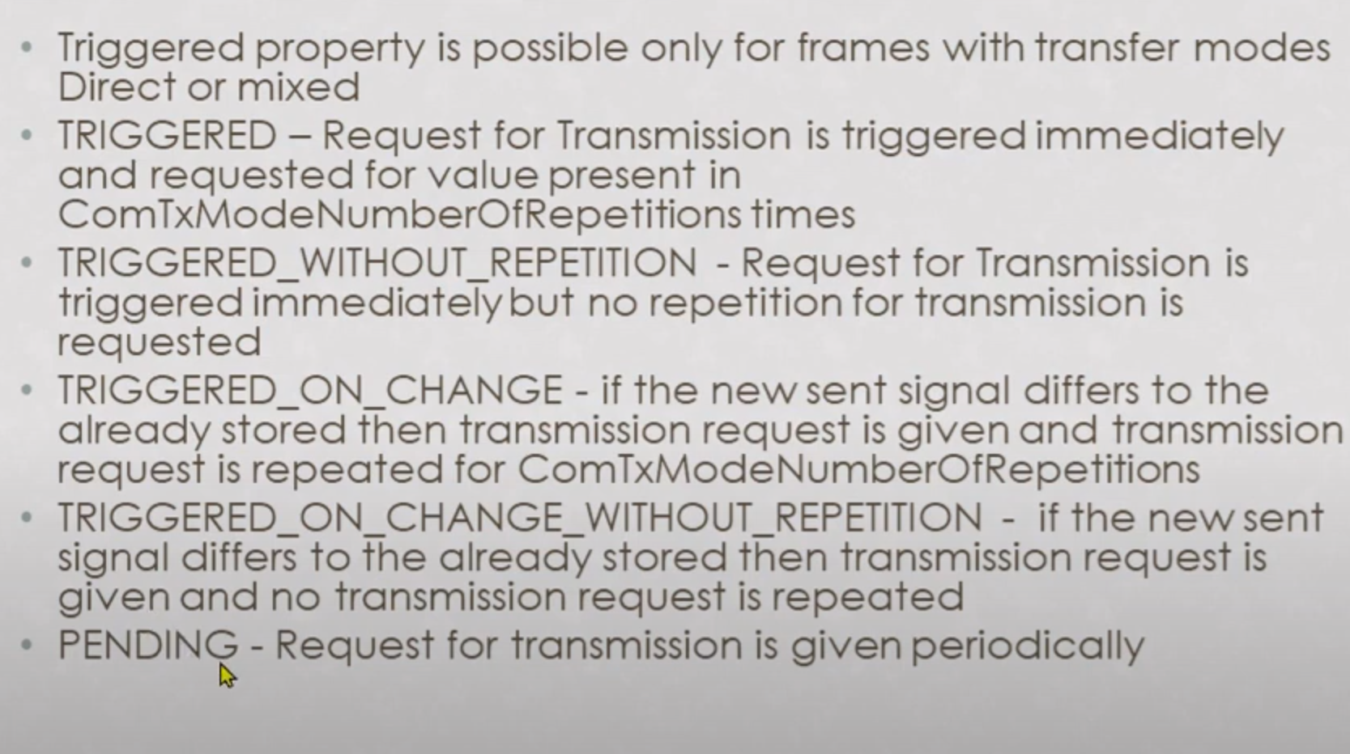

**Signals**

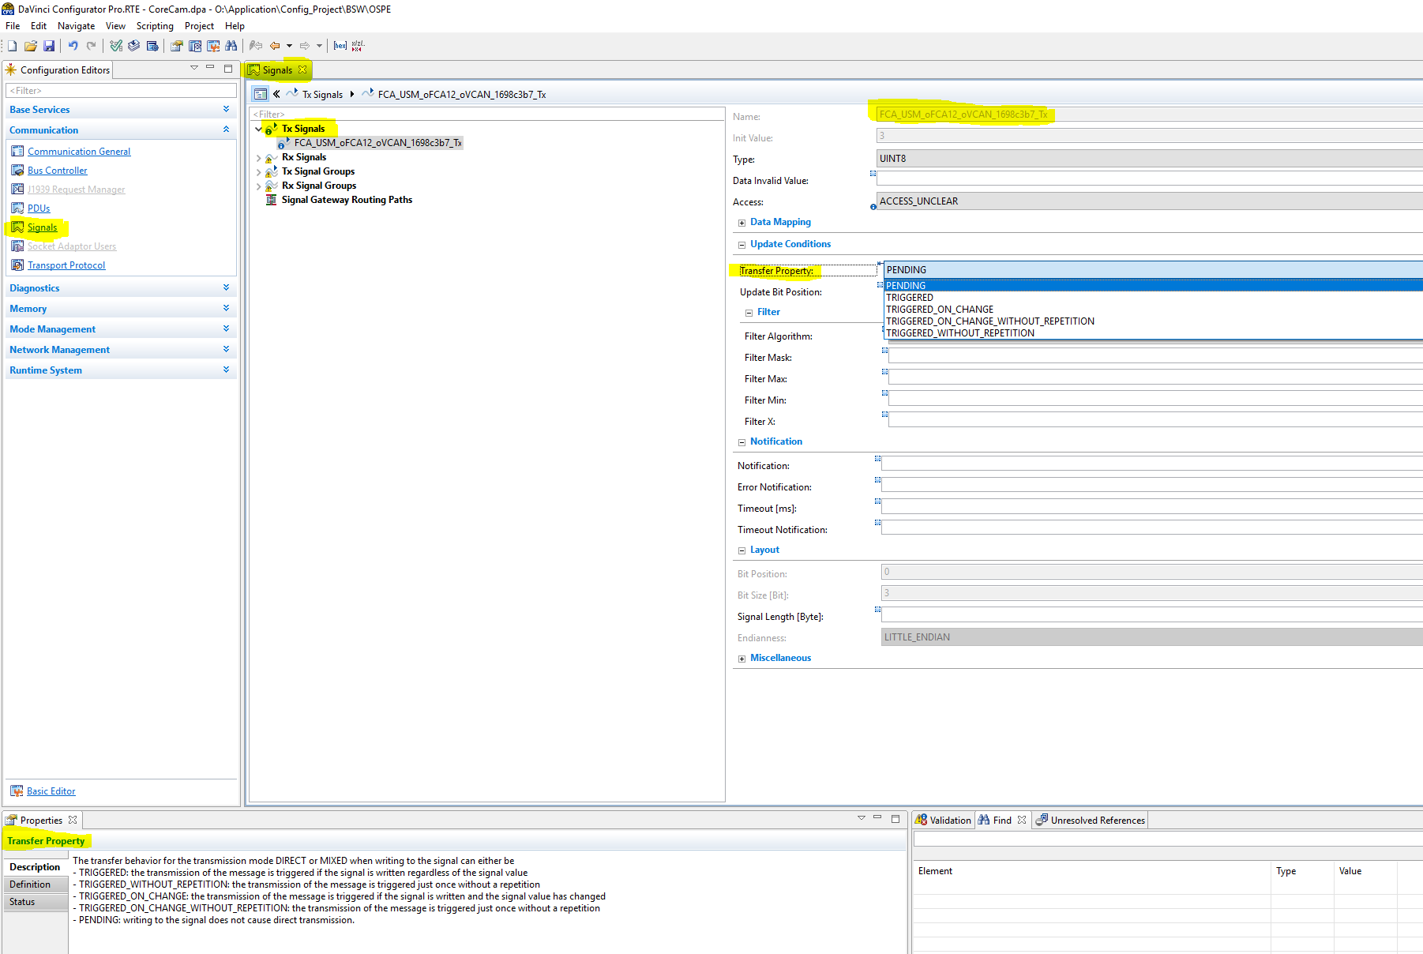

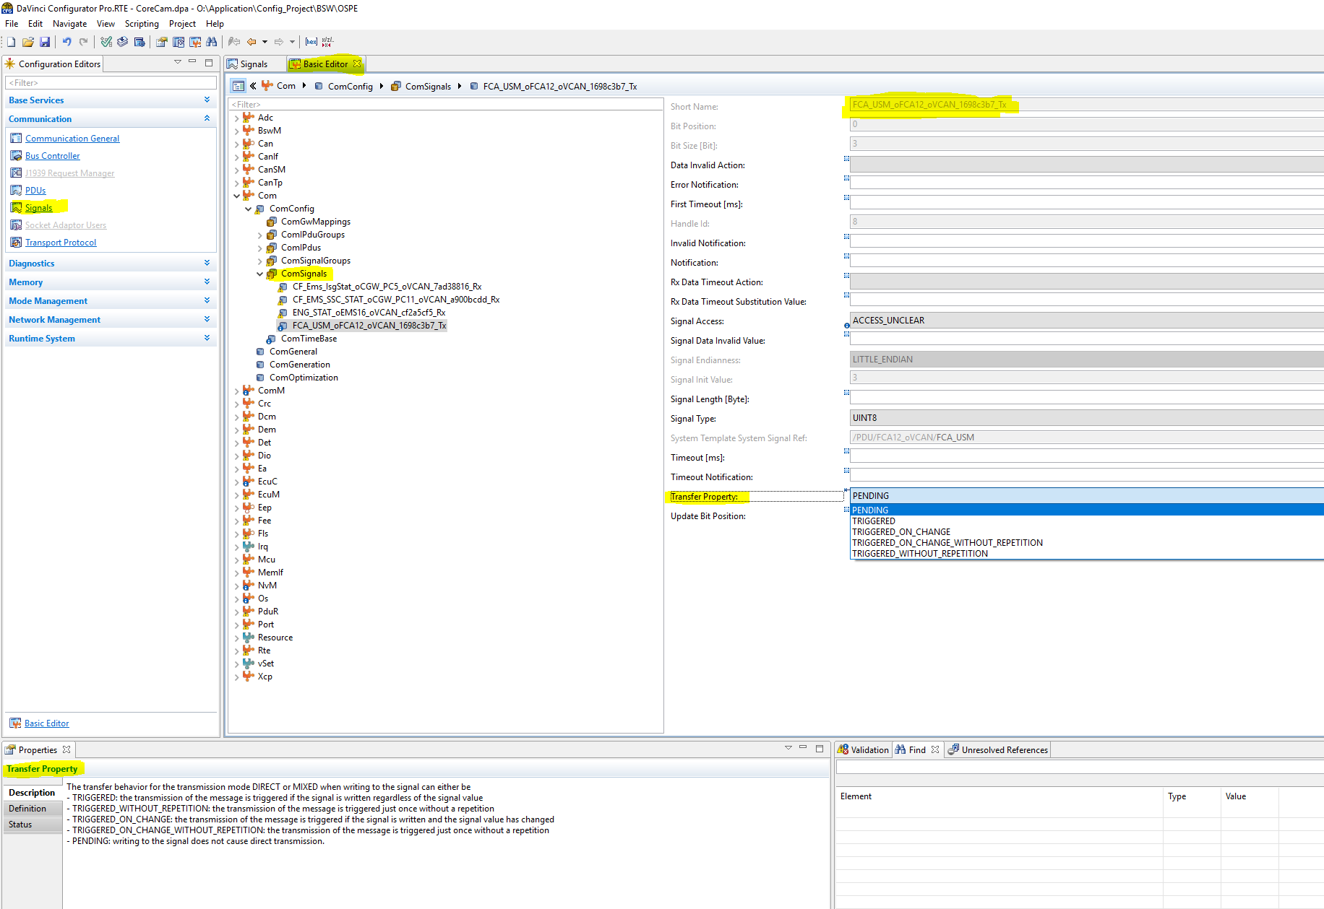

**Signal Group**

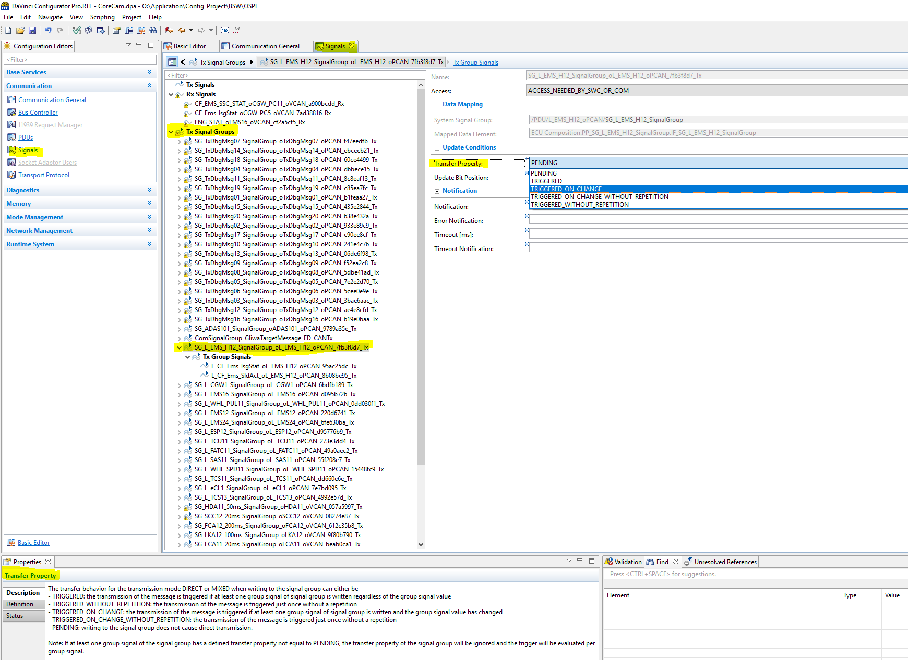

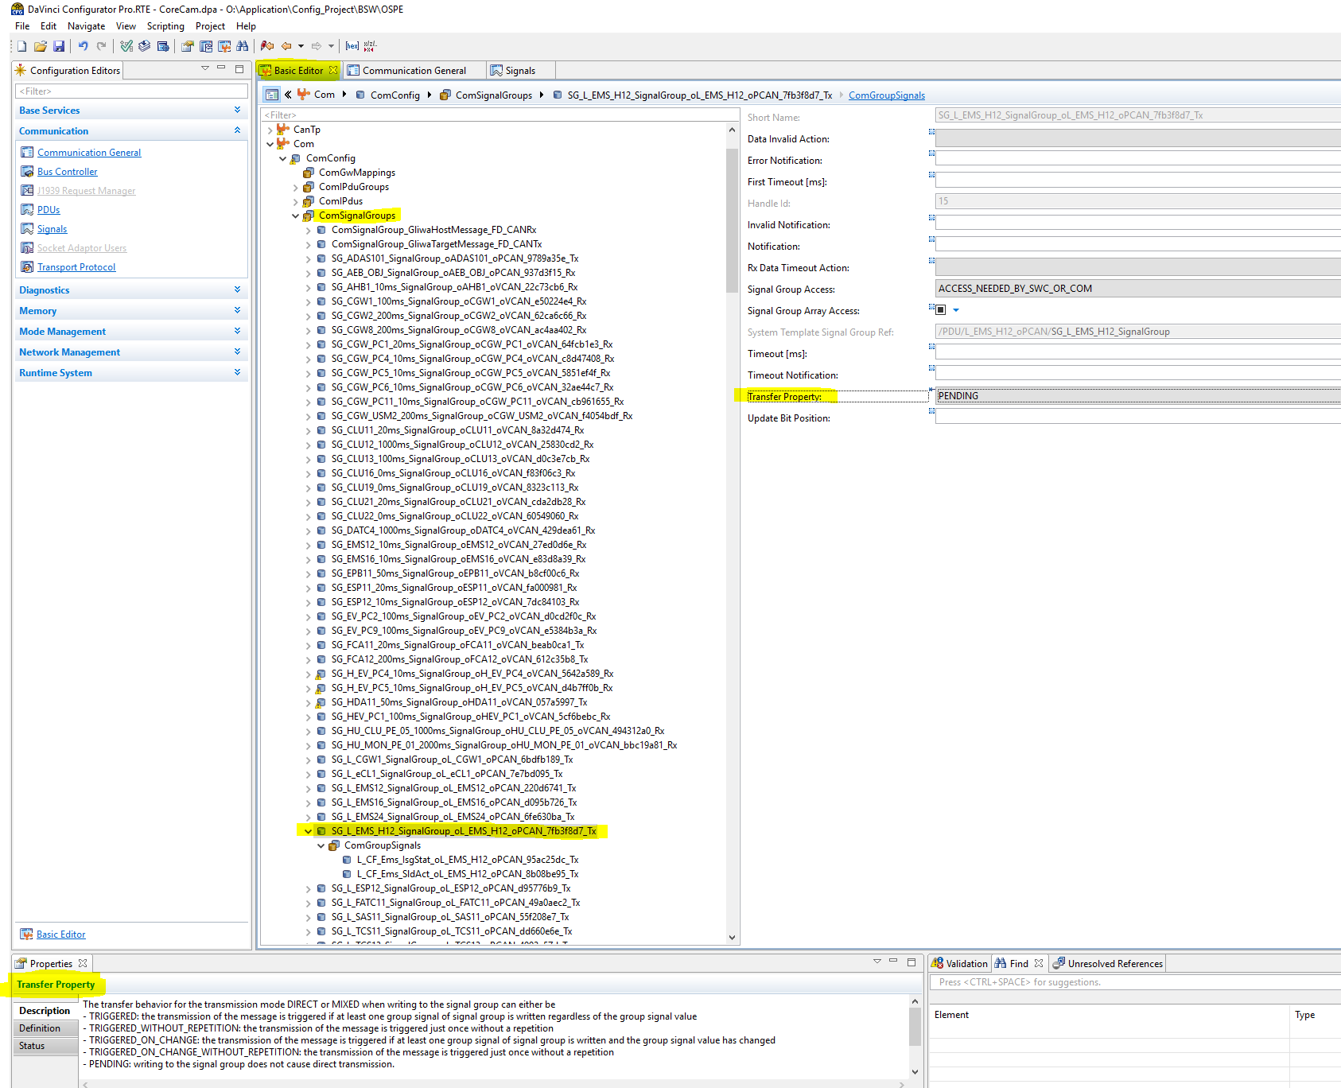

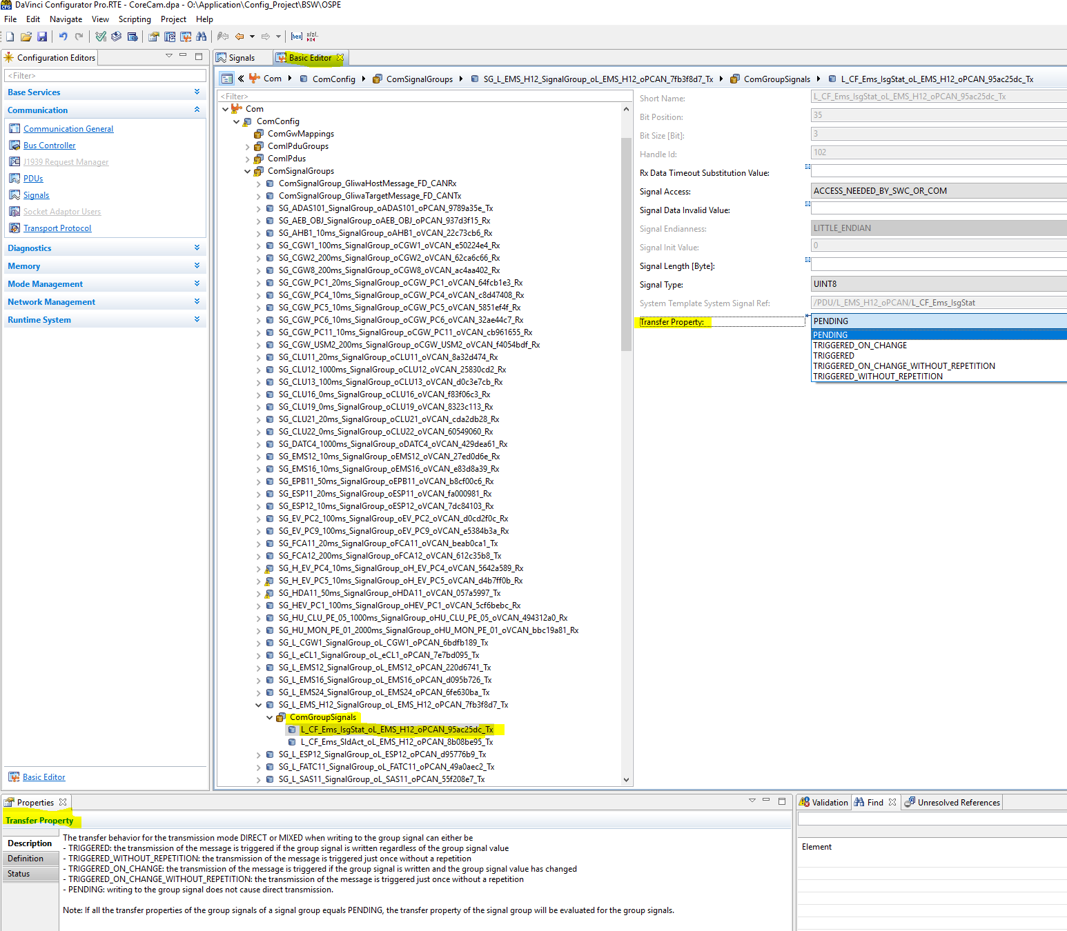

Signal Not present in signal group then where it is configured in Davinci.

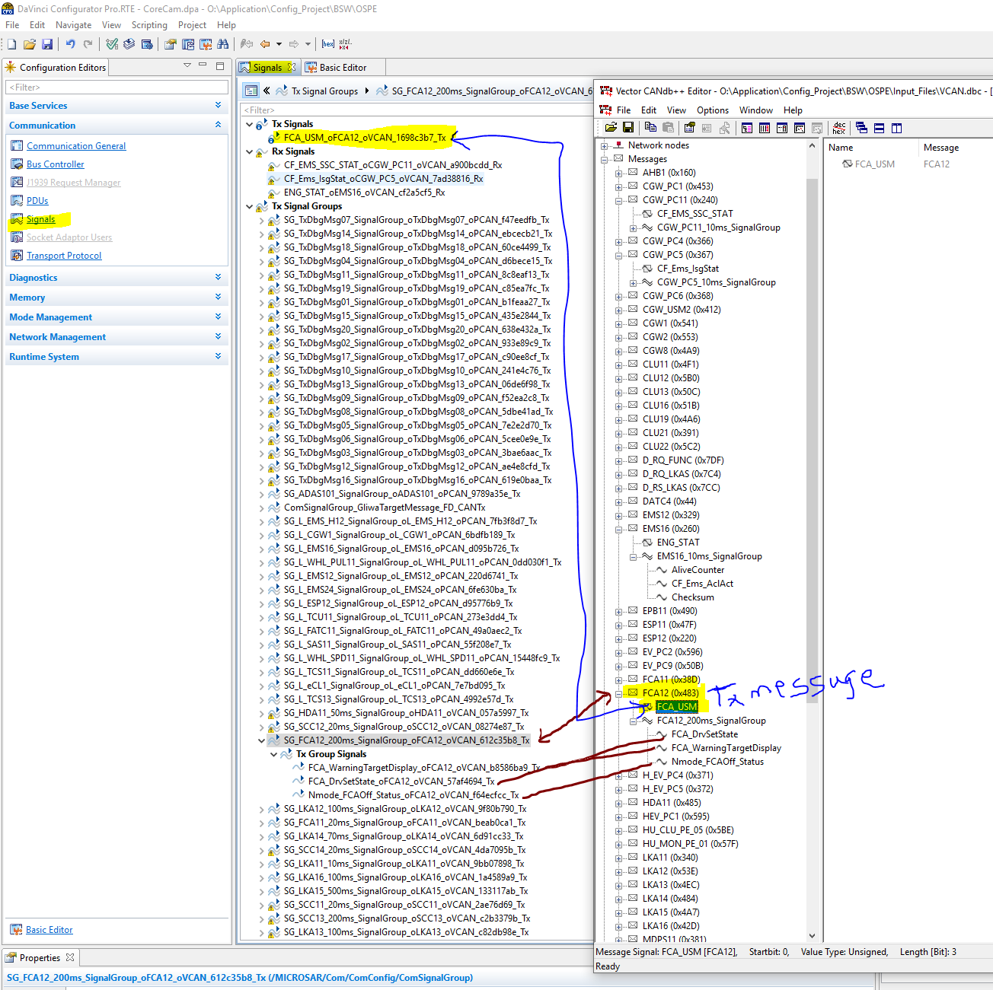

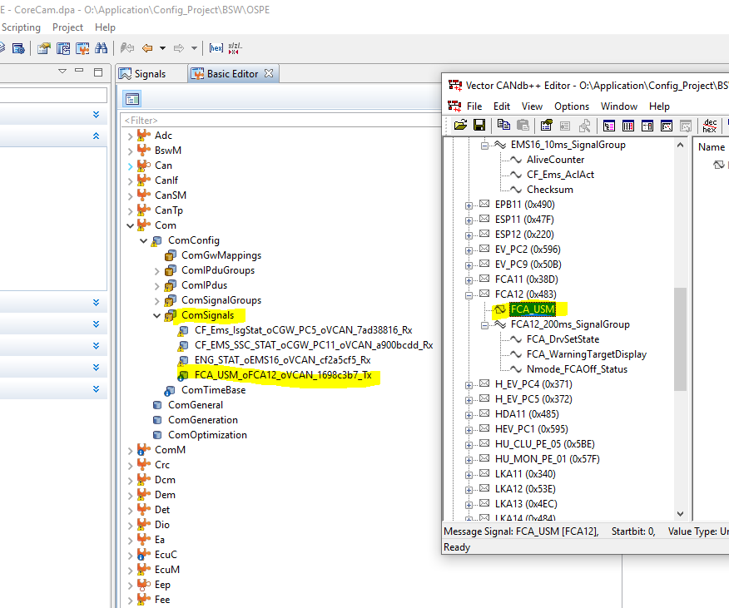

1. **ComTransmissionMode**

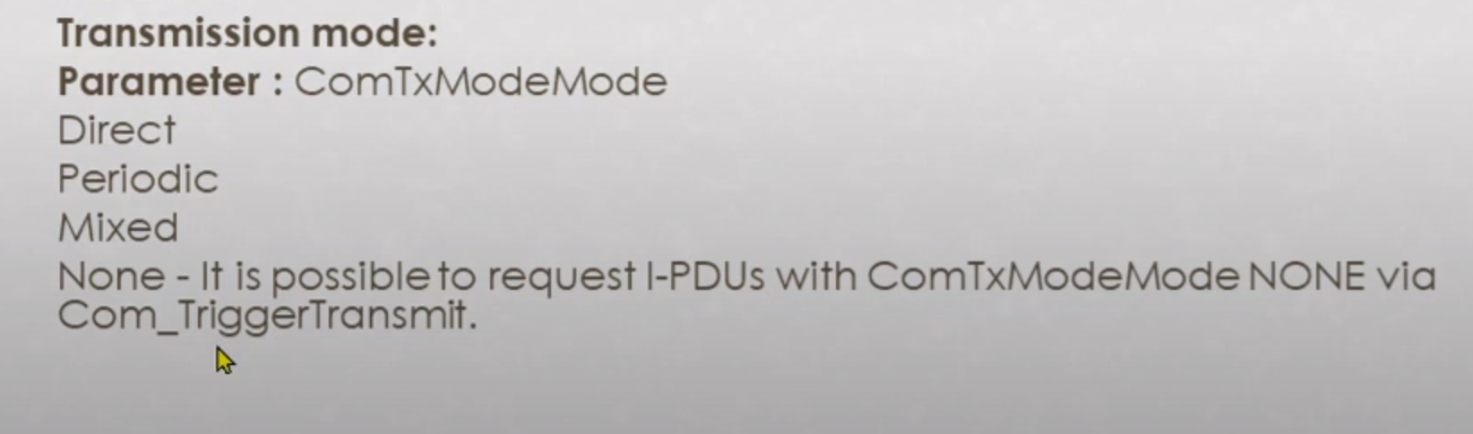

(Check Digram in Vector training doc page 17)

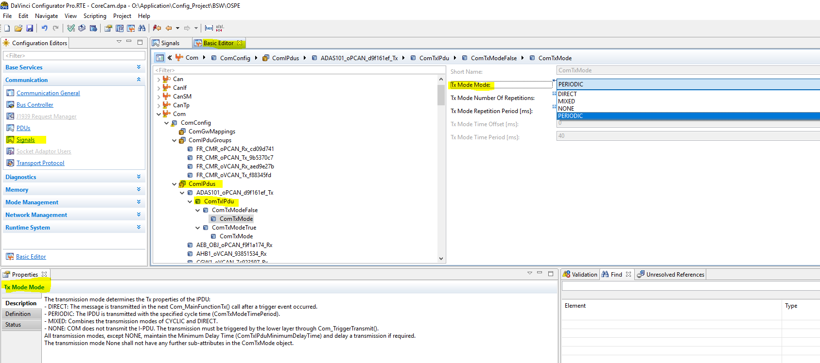

**Transmission of a Signal**

1. To request the transmission of a signal, the upper layer uses the API **Com_SendSignal.**
2. After performing optional parameter checks COM updates the I-PDU with the new signal value and checks if the transfer property of the signal requires a direct transmission.
3. If yes, a flag is set which is evaluated later in the cyclic main function of the COM layer’s transmit part.
4. Transmission modes of the I-PDU are handled in the **Com_MainFunctionTx**. This means that the actual transmit request to the underlying layer is always decoupled from the upper layer.
5. In the transmission mode handler cyclic transmissions and direct transmissions are processed.

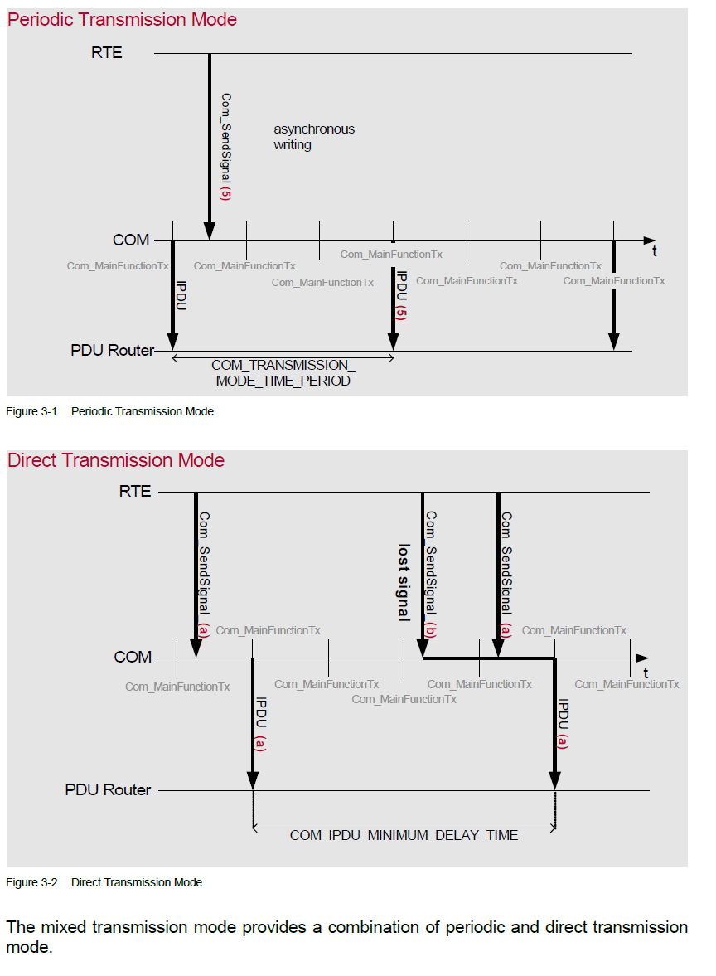

**Transmission of a Signal Group**

AUTOSAR COM provides signal groups to send several signals consistently. Signals

mapped to a signal group are called group signals and should be in relationship with each other. To ensure the consistency of the group signal values, **a shadow buffer** is provided for each signal group.

To request the transmission of a signal group with several group signals, following

sequence of API calls must be followed:

**Example**

/* Update the group signal values in the shadow buffer */

Com_SendSignal(GroupSignal1, &SigBuffer1);

Com_SendSignal(GroupSignal2, &SigBuffer2);

/* Copy the shadow buffer to the Tx buffer */

Com_SendSignalGroup(SignalGroupA);

ComGroupSignal : Signals mapped to a signal group

ComSignalGroup : COM provides signal groups to send several signals consistently

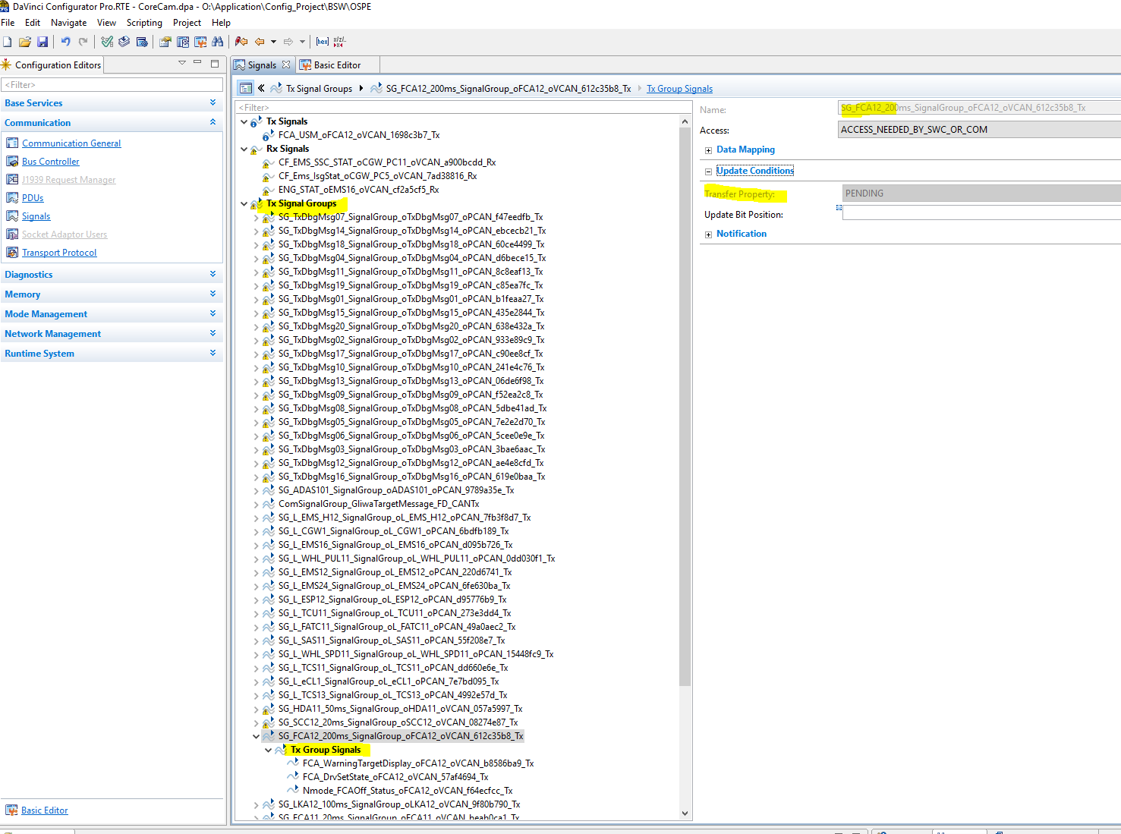

No Transfer Property for individual signals within the Group Signals because this property is belong to Signal Groups as shown in images

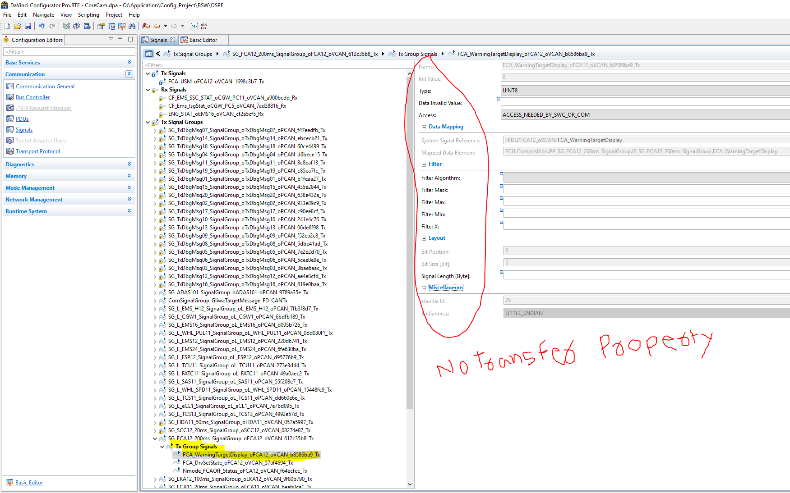

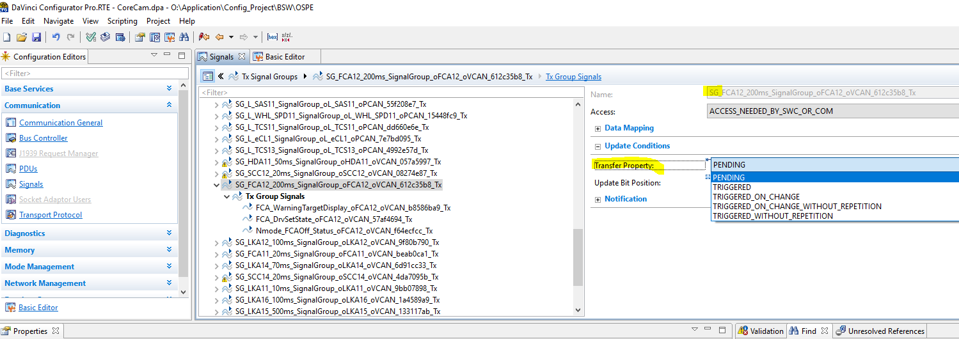

ComGroupSignal

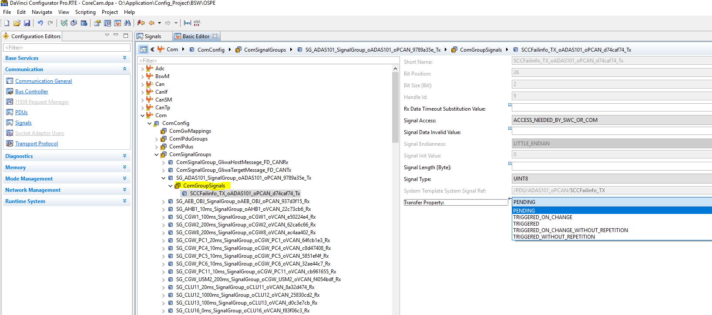

ComSignalGroup

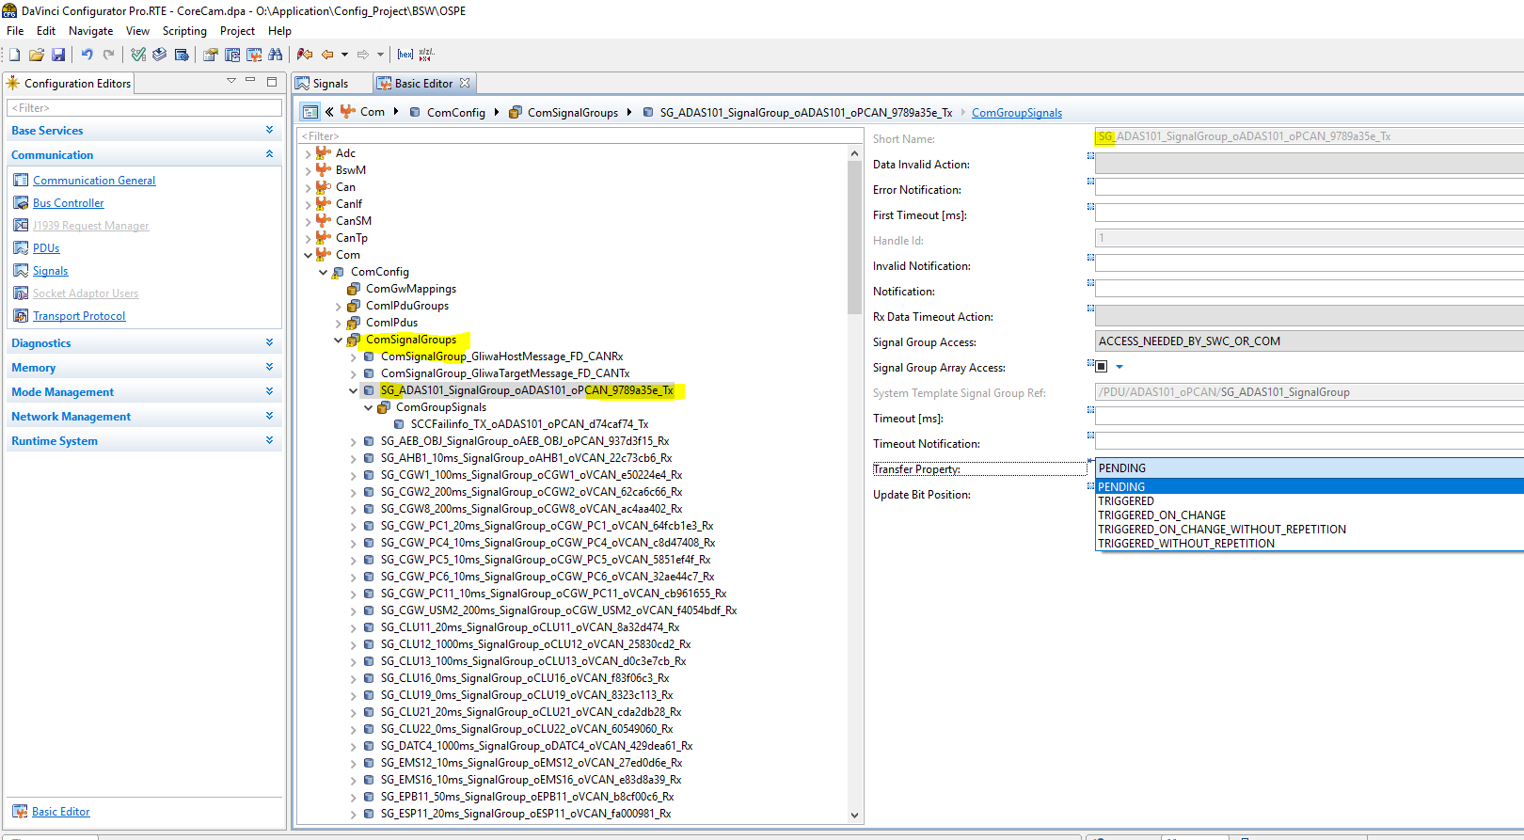

For the transmission modes DIRECT or MIXED the evaluation of the transfer property is

handled as follows

1. ComSignalGroup.ComTransferProperty equals TRIGGERED and all ComGroupSignal.ComTransferProperty equals PENDING

**Com_SendSignal(ComGroupSignal) -> Com_SendSignalGroup(ComSignalGroup)**

will trigger a transmission of the Tx I-Pdu regardless of the group signal value.

1. ComSignalGroup.ComTransferProperty equals TRIGGERED_ON_CHANGE and all ComGroupSignal.ComTransferProperty equals PENDING

**Com_SendSignal(ComGroupSignal) -> Com_SendSignalGroup(ComSignalGroup)**

will trigger a transmission of the Tx I-Pdu if at least one group signal value has

changed.

1. ComSignalGroup.ComTransferProperty equals PENDING

ComGroupSignal.ComTransferProperty equals TRIGGERED

**Com_SendSignal(ComGroupSignal) -> Com_SendSignalGroup(ComSignalGroup)**

will trigger a transmission of the Tx I-Pdu regardless of the group signal value.

1. ComSignalGroup.ComTransferProperty equals PENDING

ComGroupSignal.ComTransferProperty equals TRIGGERED_ON_CHANGE

**Com_SendSignal(ComGroupSignal) -> Com_SendSignalGroup(ComSignalGroup)**

will trigger a transmission of the Tx I-Pdu if the group signal value has changed.

1. ComSignalGroup.ComTransferProperty equals PENDING

ComGroupSignal.ComTransferProperty equals PENDING

**Com_SendSignal(ComGroupSignal) -> Com_SendSignalGroup(ComSignalGroup)**

will not trigger a transmission of the Tx I-Pdu.

1. **ComTransmissionModeSelection**

After a send request from the RTE for a specific signal, the signal is written to the

appropriate I-PDU buffer as defined by configuration, and the selection of the trans-

mission mode of the I-PDUs is done

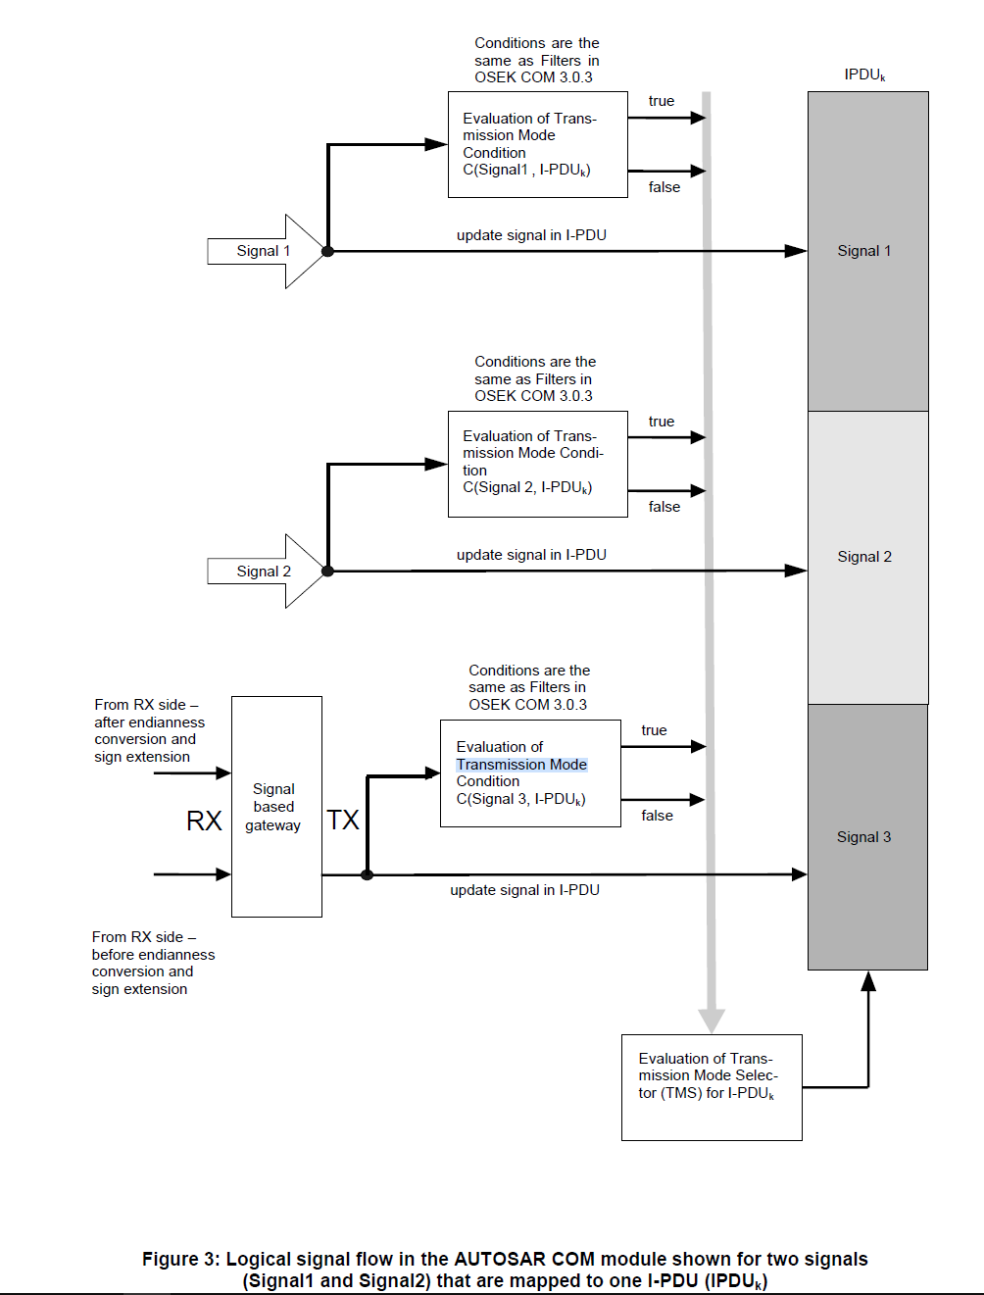

AUTOSAR COM allows configuring two different transmission modes for each I-PDU

(ComTxModeTrue and ComTxModeFalse). The transmission mode of an I-PDU that is

valid at a specific point in time is selected using only the filter states of the signals that are

mapped to this I-PDU.

If a filter of any signal mapped to a specific I-PDU evaluates to TRUE, this I-PDU is

transmitted with transmission mode TRUE. The transmission mode FALSE is used for an IPDU when the filters of all signals mapped to this I-PDU evaluate to FALSE.

If all signals mapped to a specific I-PDU have no filter assigned, the transmission mode

evaluates to TRUE and does never change.

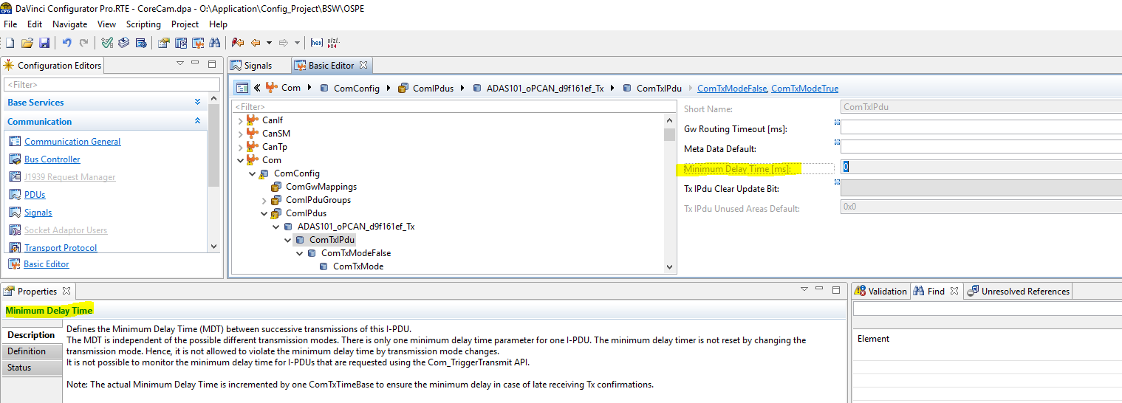

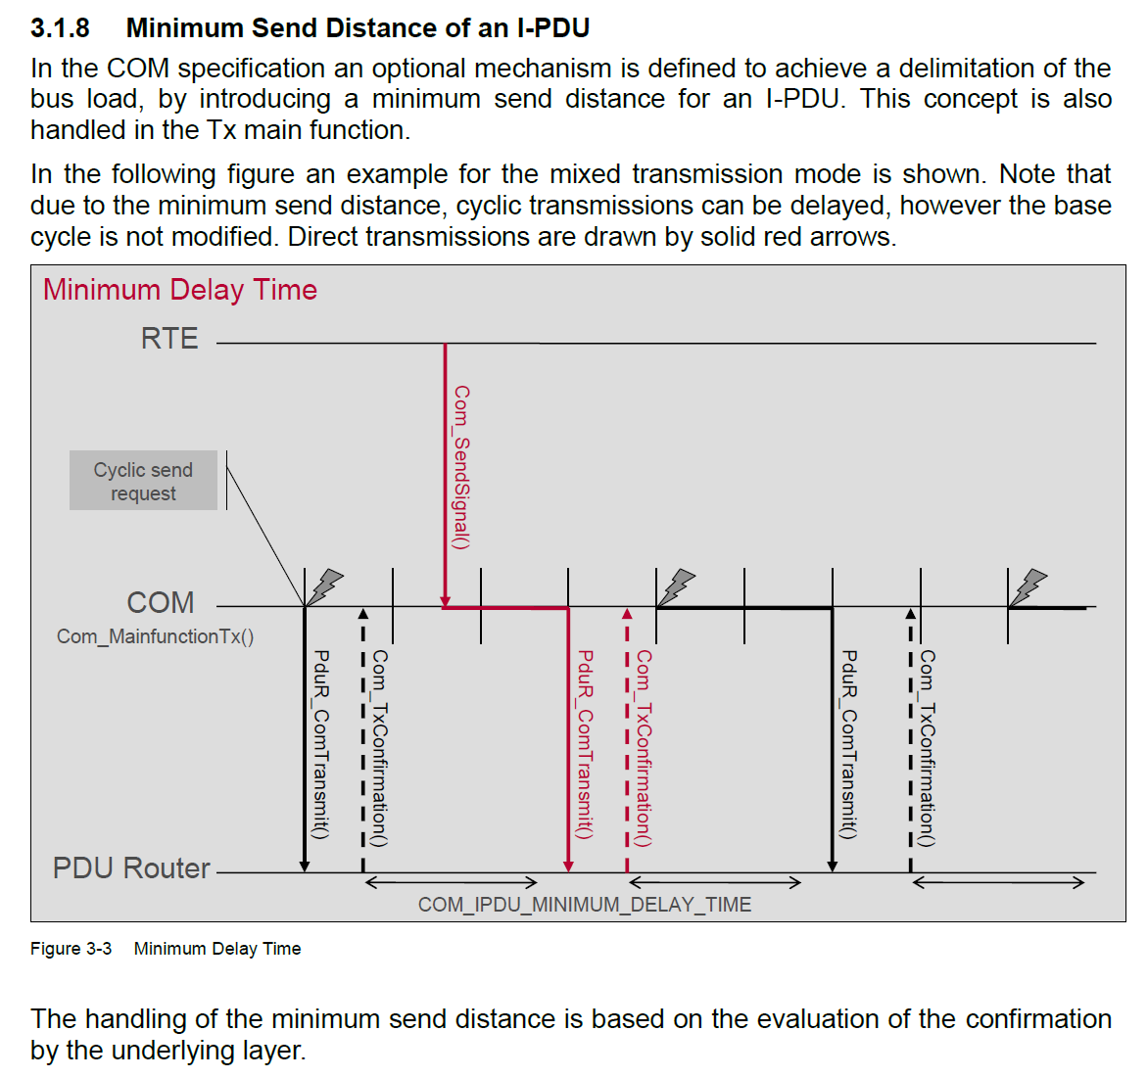

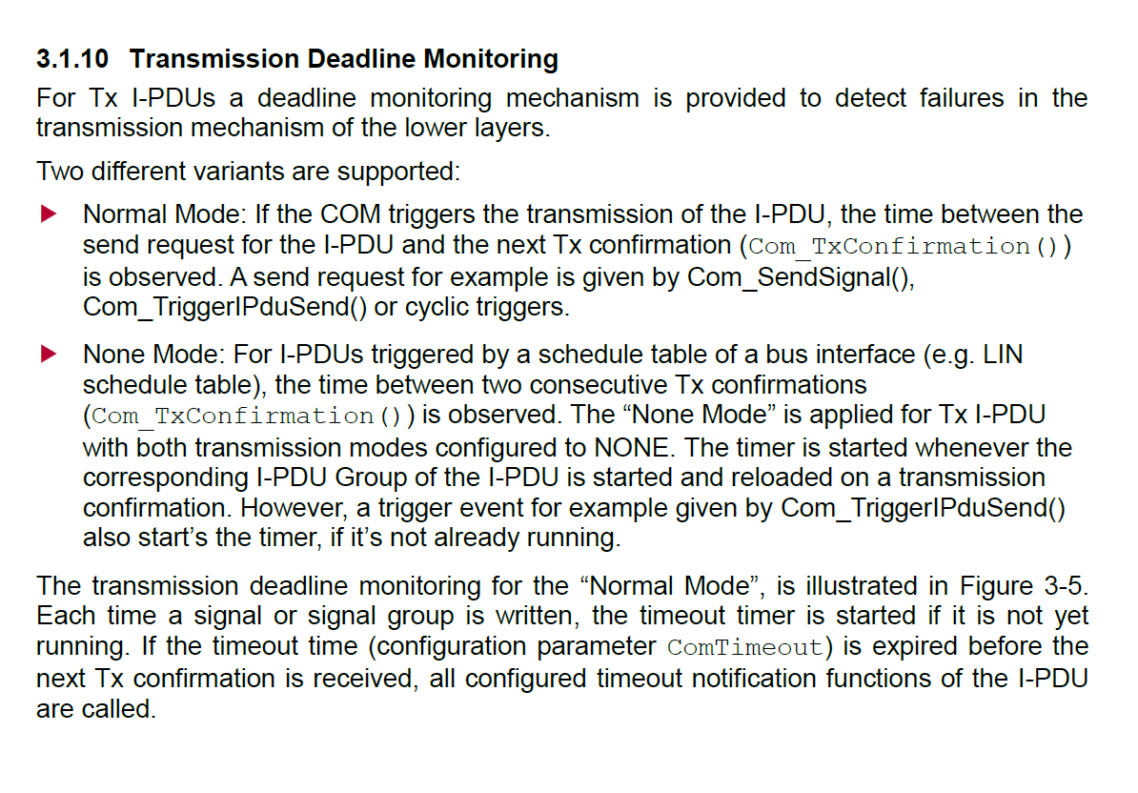

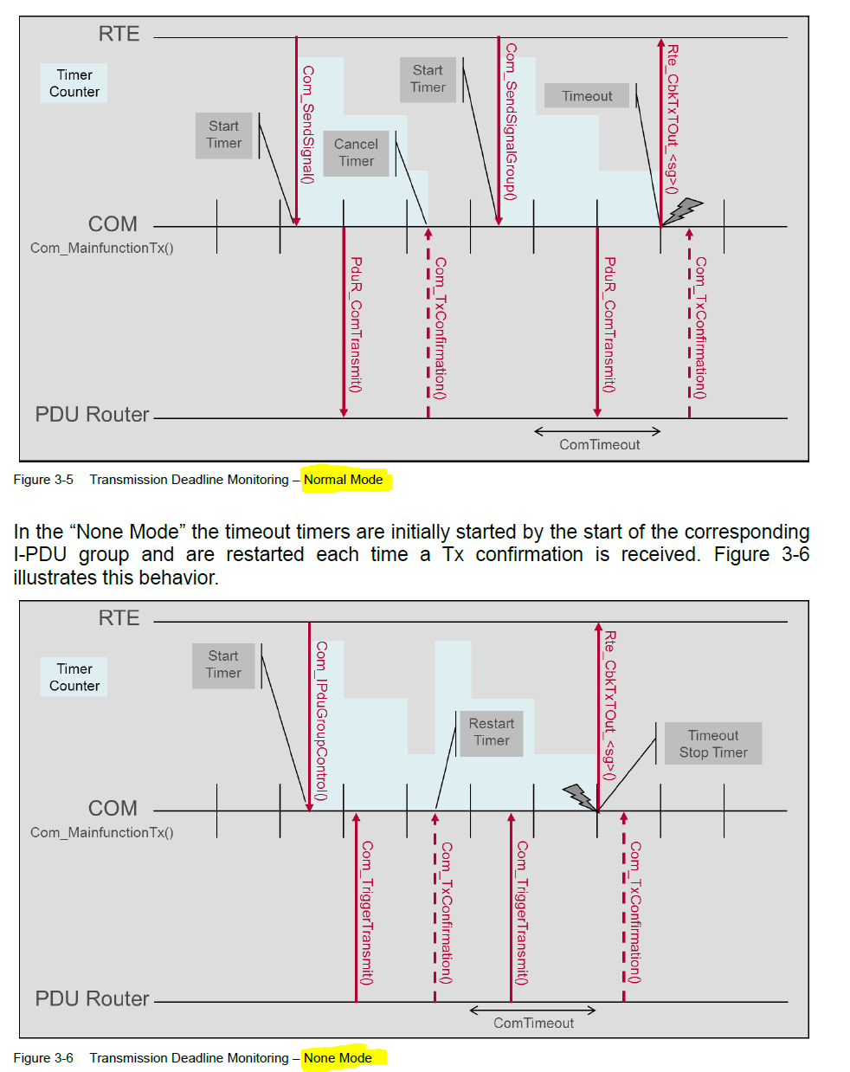

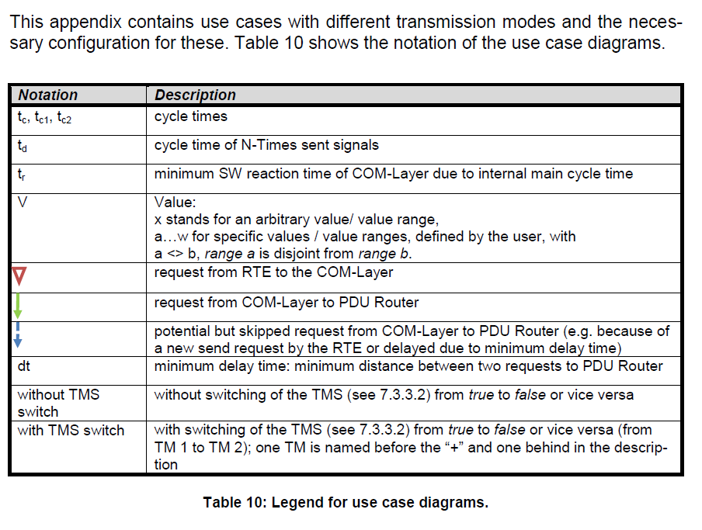

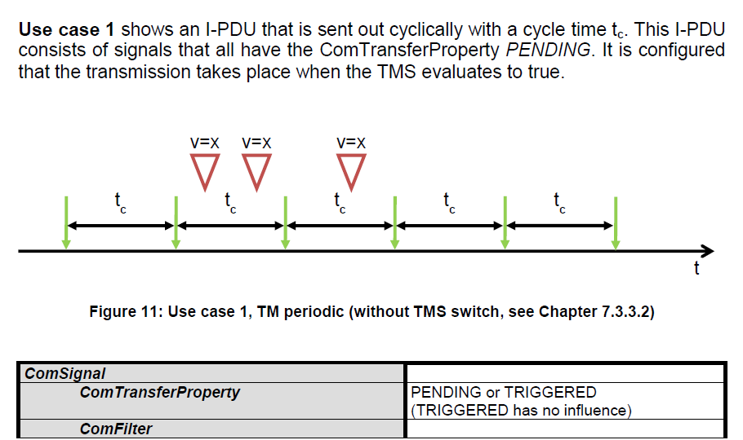

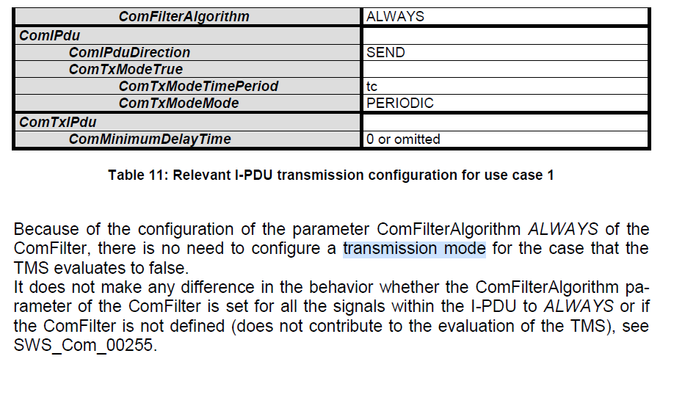

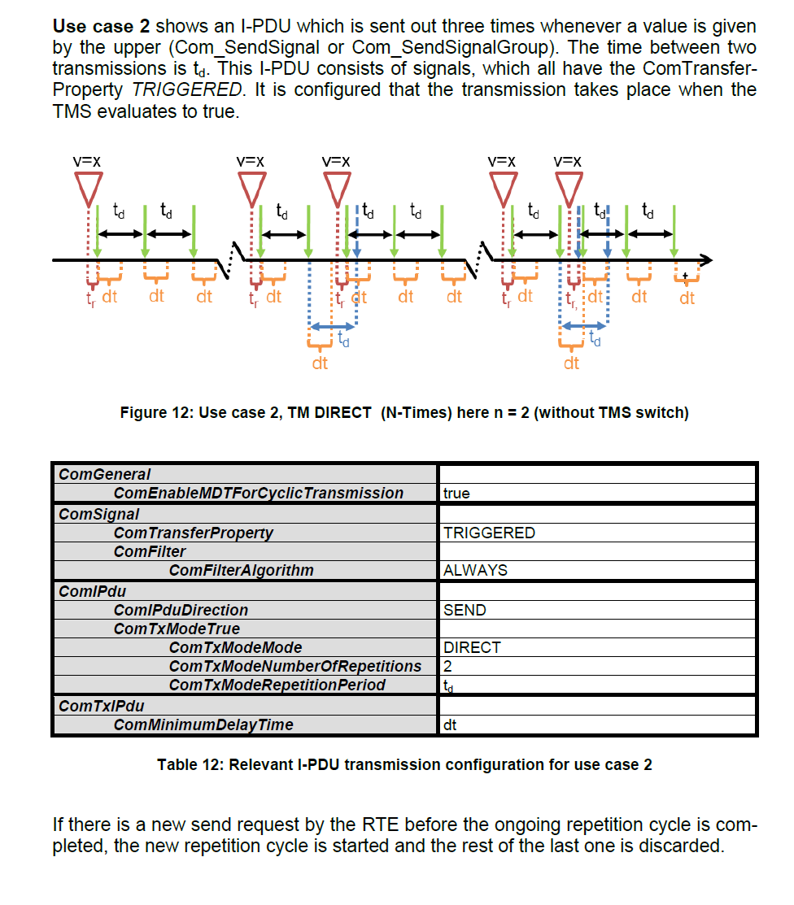

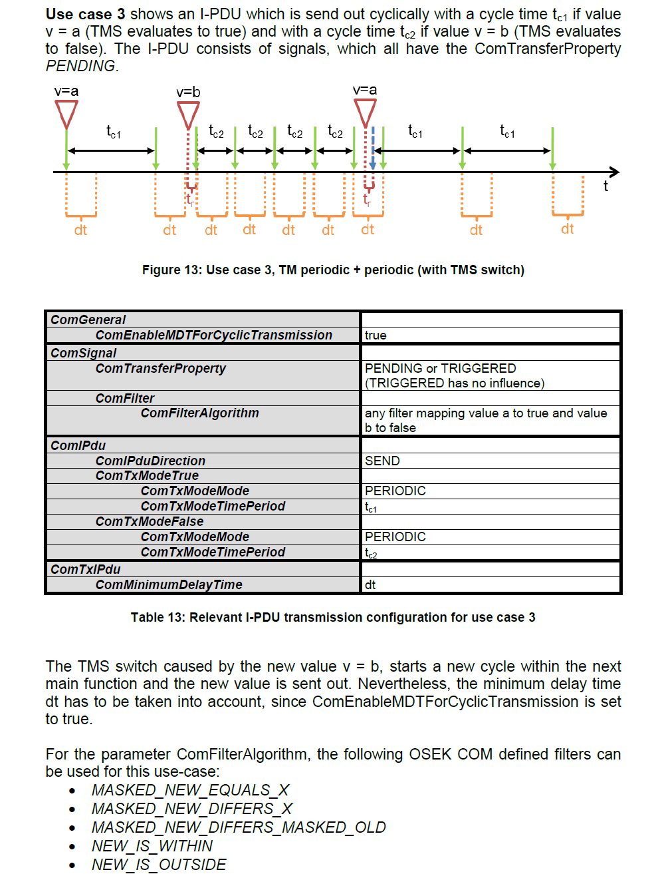

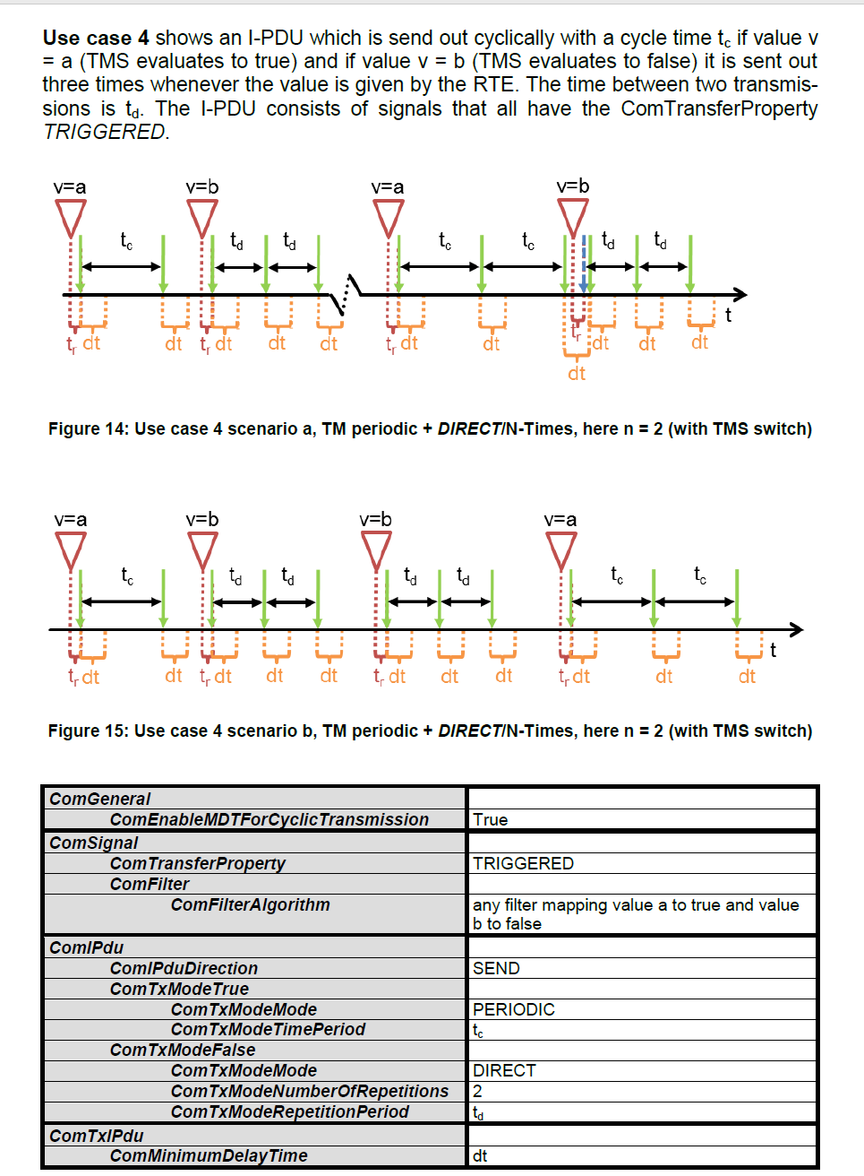

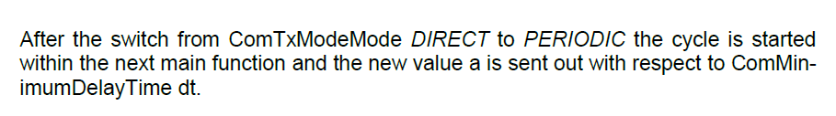

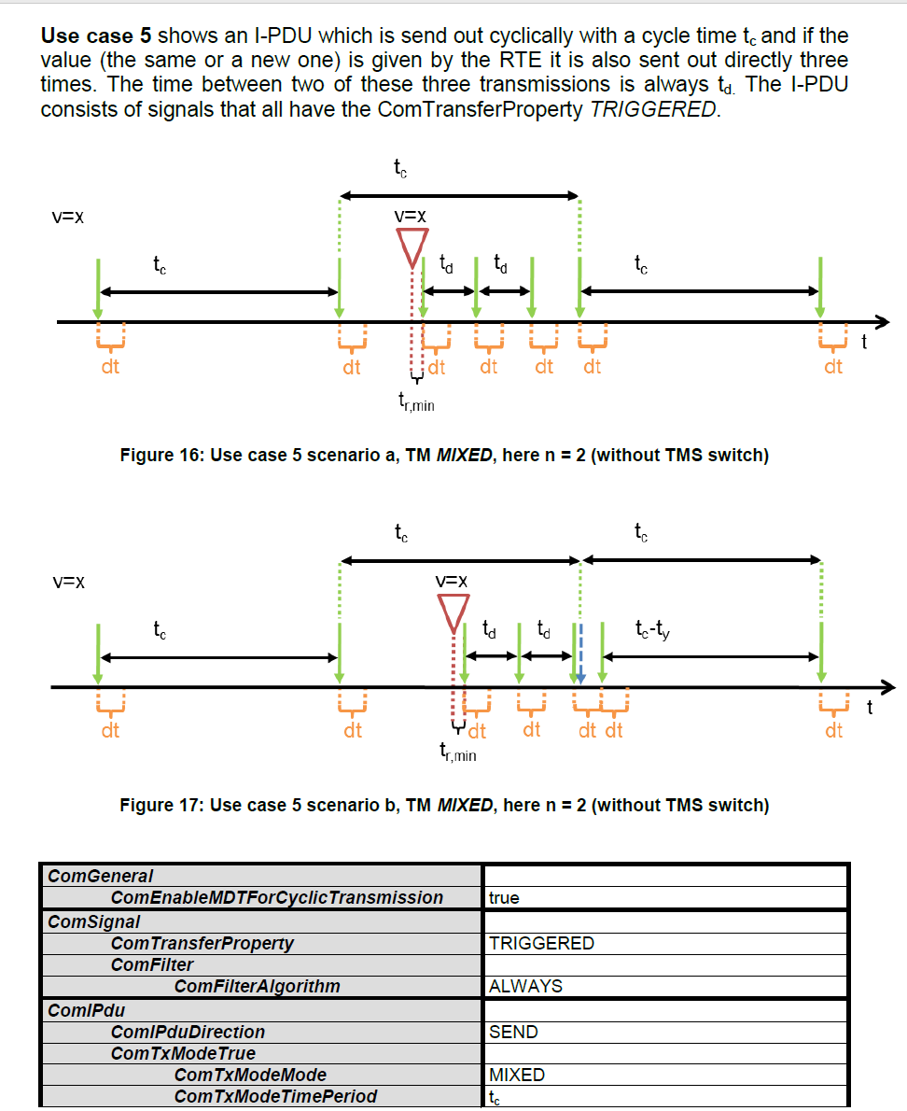

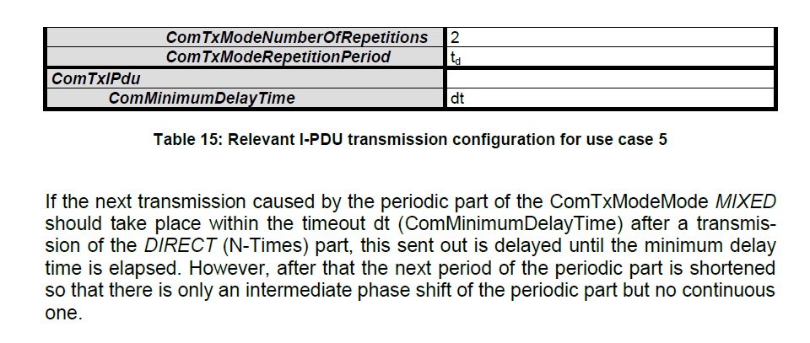

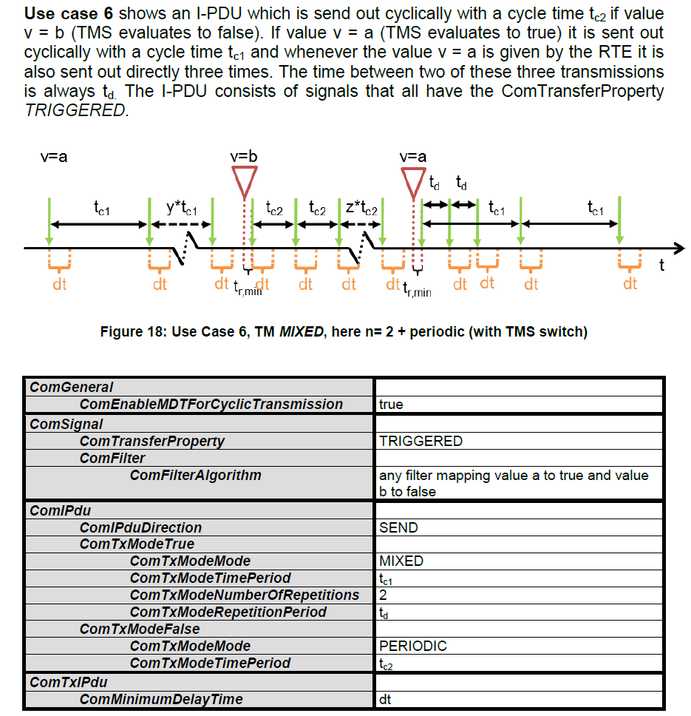

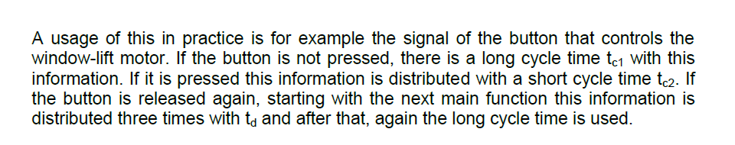

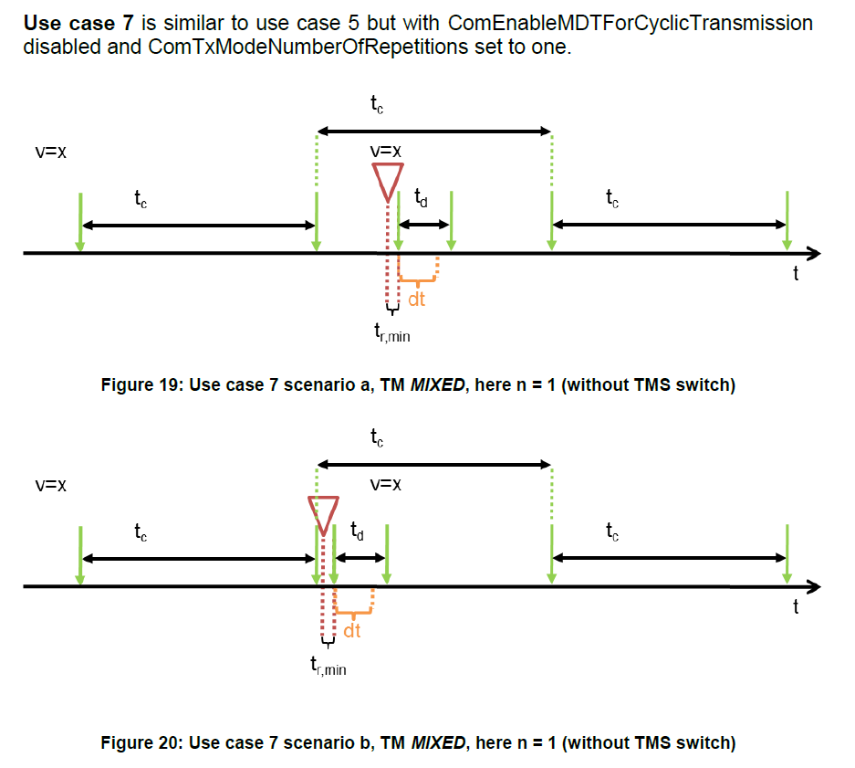

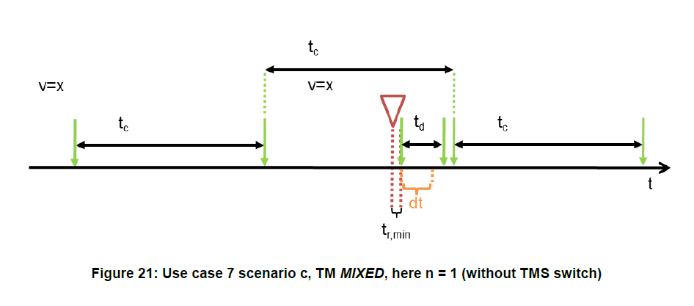

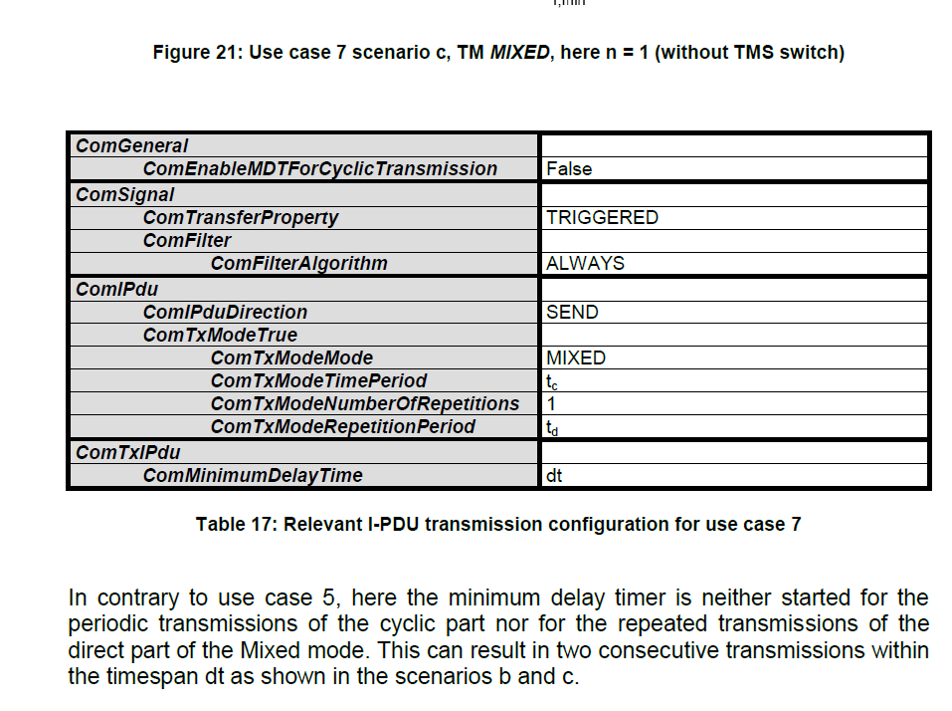

**The AUTOSAR COM module’s interaction model for reception**

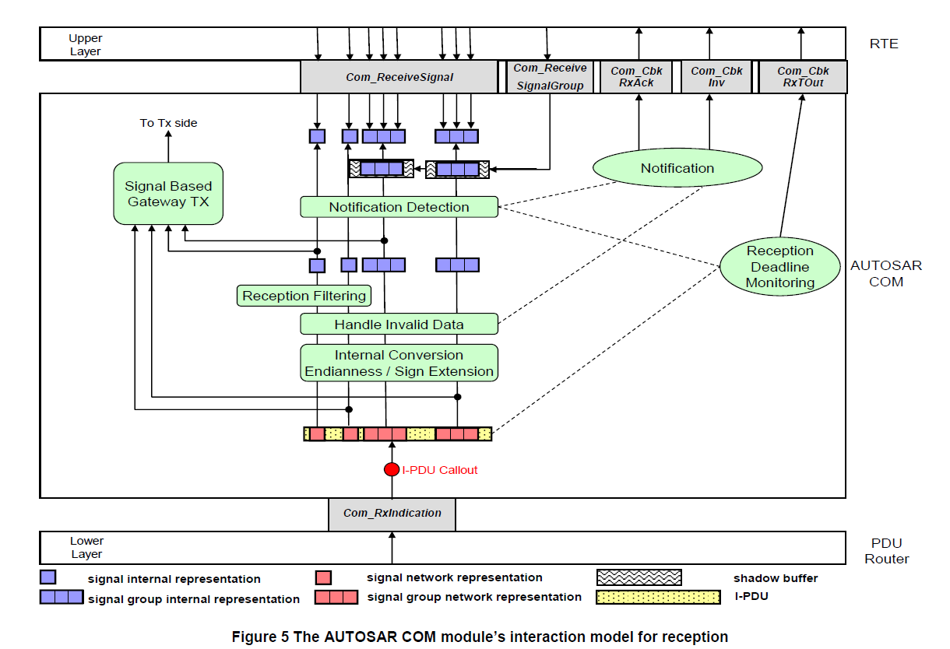

To receive a signal the upper layer uses the API **Com_ReceiveSignal.** This service

delivers the signal value which is contained in the latest I-PDU of the signal.

As the signal processing context depends on the configuration of the corresponding Rx IPDU, the latest signal value might not be available until the next call to

Com_MainfunctionRx.

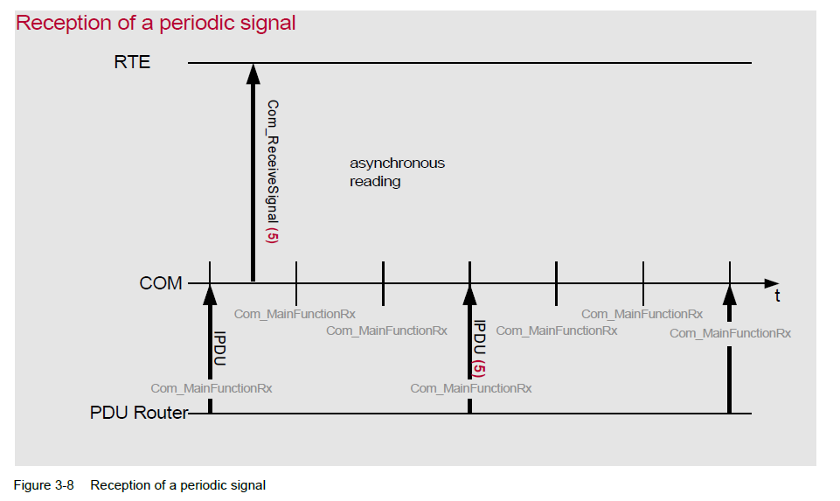

The reception procedure of the signal is usually asynchronous to the reception of the IPDU.

A call to Com_ReceiveSignal always returns the last received signal value or the initial value if a timeout occurred and the Rx Data Timeout Action is set to REPLACE, even if the corresponding I-PDU group is stopped.

**Reception of a Signal Group**

AUTOSAR COM provides **signal groups** to receive several signals consistently. Signals mapped to a signal group are called **group signals** and should be in relationship with each other. To ensure the consistency of the group signal values a shadow buffer is provided for each signal group.

As the signal processing context depends on the configuration of the corresponding Rx IPDU, the latest signal group value might not be available until the next call to

**Com_MainfunctionRx**.

To receive the values of a signal group with several group signals, following sequence of API calls must be followed:

**Example**

**/* Copy the Rx buffer to the shadow buffer */**

Com_ReceiveSignalGroup(SignalGroupA);

**/* Get the group signal values from the shadow buffer */**

Com_ReceiveSignal(GroupSignal1, &SigBuffer1);

Com_ReceiveSignal(GroupSignal2, &SigBuffer2);

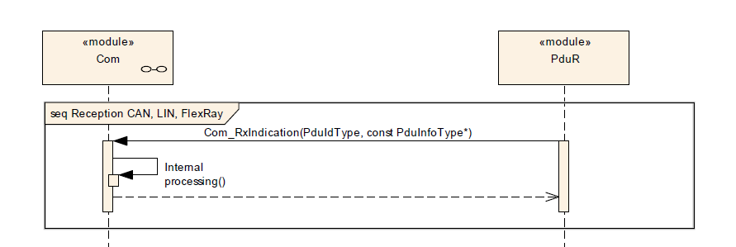

**Confirmation Handling between the PDU Router, the AUTOSAR COM Module and the RTE**

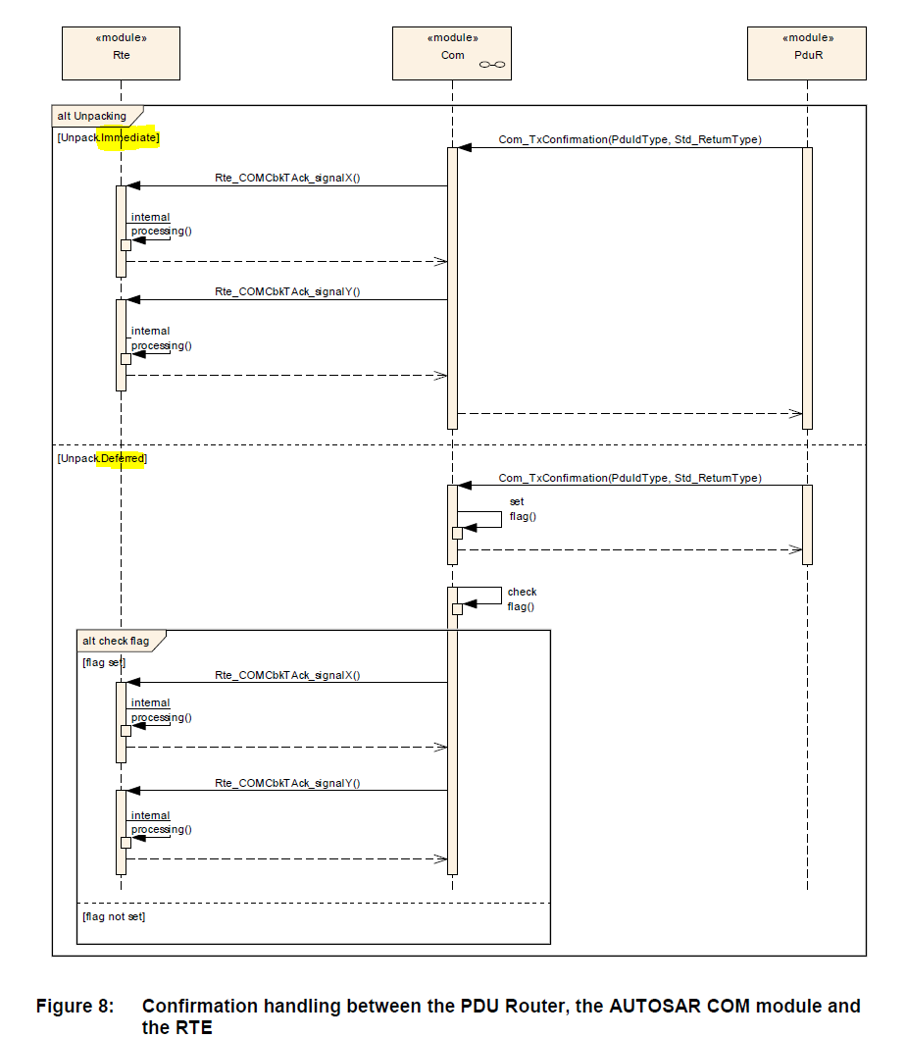

**Indication Handling between the PDU Router, the AUTOSAR COM Module and the RTE**

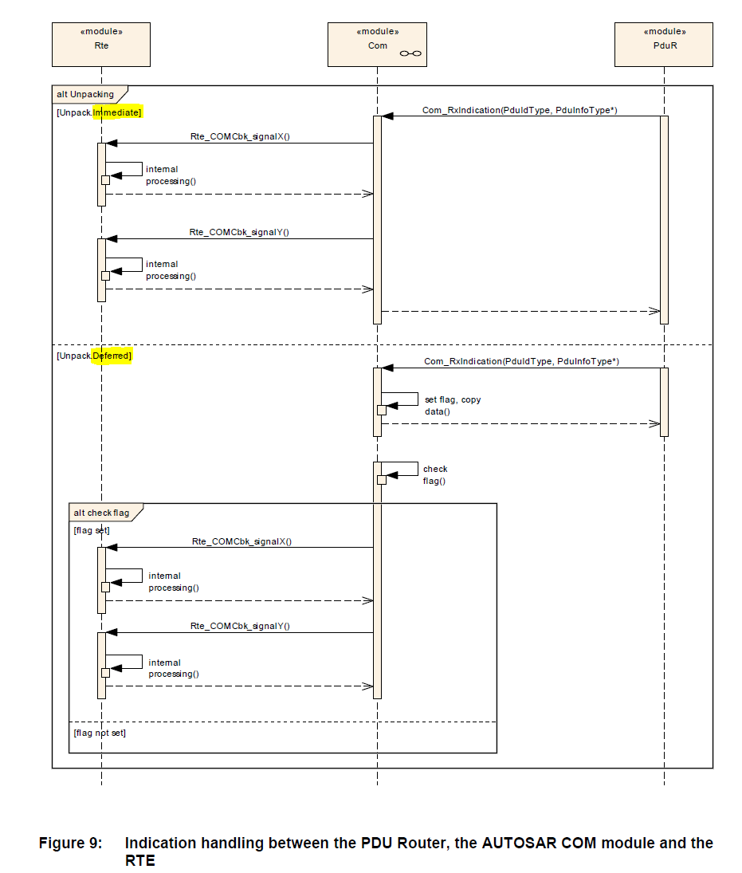

**Dynamic DLC**

The COM evaluates the actual received DLC of the SDU given from the lower layer

interface to support the reception of Rx I-PDUs **with a variable length**.

Two cases are distinguished:

1. **Actual received DLC is greater than or equal to the statically configured**
2. Only the SDU payload data with the statically configured PDU length is processed.
3. Normal signal processing.
4. **Actual received DLC is smaller than the statically configured**
5. Only the SDU payload data with the actual received PDU length is processed.
6. Only completely received signals or signal groups are processed.

This affects:

* + - * 1. Rx indication notifications
        2. Rx Filter
        3. Rx Invalidation
        4. Signal routing

**Reception Deadline Monitoring**